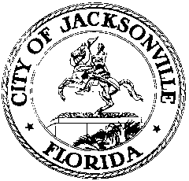

OFFICE OF THE CITY COUNCIL

117 WEST DUVAL STREET, SUITE 425
4TH FLOOR, CITY HALL
JACKSONVILLE, FLORIDA 32202
904-630-1377

CIVIL RIGHTS HISTORY FINANCE SUBCOMMITTEE MINUTES
Lynwood Roberts Room, 1st Floor, City Hall
May 23, 2018
10:00 a.m.

Location: Lynwood Roberts Room, 1st floor, City Hall – St. James Building, 117 West Duval Street

In attendance: Chris Hand (Co-Chair)

Also: Annette Hastings – Tourist Development Council (TDC); Yvonne P. Mitchell – Council Research Division

Meeting Convened: 9:12 a.m.

Mr. Chris Hand, Co-Chair, convened the meeting. No other members were present. Mr. Hand acknowledged Ms. Annette Hastings, TDC Executive Director, and requested she attend the next subcommittee meeting to provide a presentation. There was no public comment. The next subcommittee meeting is June 6, 2018.

There being no further business, the meeting was adjourned.

Meeting adjourned: 9:16 a.m.

Minutes: Yvonne P. Mitchell, Council Research
Posted 05.23.18 10:00 a.m.

Tapes: Civil Rights History Finance Subcommittee - LSD
05.23.18

Handouts: Civil Rights History Finance Subcommittee
05.23.18

